**Programme:** GEN

**Project/WP:** Electronic Engineering Department

CRISLER Monitoring USER MANUAL

**Document Number:**

**Document Version:** 0.3

**Document Type:** Manual (MAN)

**Released On:**

**Document Classification:** ESO Internal [Confidential for Non-ESO Staff]

|  |  |
| --- | --- |
| **Prepared by:** | Benoit Serra |
| **Validated by:** |  |
| **Approved by:** |  |
|  | Name |

Authors

|  |  |
| --- | --- |
| **Name** | **Affiliation** |
| Benoit Serra | ESO |
|  |  |
|  |  |
|  |  |
|  |  |

Change Record from previous Version

|  |  |
| --- | --- |
| **Affected Section(s)** | **Changes / Reason / Remarks** |
| All | Initial drafting |
| 5 Data Visu. | Adding section for visualisation of data logs from CRIMON |
| All | Adding the instrumentation config file |
|  |  |
|  |  |

Contents

1. Introduction 4

1.1 Scope 4

1.2 Definitions, Acronyms and Abbreviations 4

2. Related Documents 4

2.1 Applicable Documents 4

2.2 Reference Documents 5

3. CRIMON description 6

3.1 Development 6

3.2 Requirements 6

3.3 Description 7

4. Operation 9

4.1 Starting the monitoring 9

Below is a step by step description of how to start: 9

4.2 Interact with the instruments 11

4.2.1 Using the GUI 11

4.2.2 Using a Python script 12

5. Data visualisation 14

5.1 Step by step 14

5.2 Notes 15

# Introduction

## Scope

This user manual covers the setup and operation of the monitoring tool CRIMON used for the CRISLER cryostat. CRISLER is a NIR detector test cryostat located in lab E.0.38 at ESO Garching. The cryostat is intended for use by expert technical staff in the detector systems group. This manual is to aid in understanding the monitoring tool as well as how to start it and how to interact with it while in operation.

## Definitions, Acronyms and Abbreviations

This document employs several abbreviations and acronyms to refer concisely to an item, after it has been introduced. The following list is aimed to help the reader in recalling the extended meaning of each short expression:

|  |  |
| --- | --- |
| TBC | To Be Clarified |
| TBD | To Be Defined |
| CRIMON | CRIsler MONitoring tool |
|  |  |
|  |  |
|  |  |
|  |  |
|  |  |
|  |  |

# Related Documents

## Applicable Documents

The following documents, of the exact version shown, form part of this document to the extent specified herein. In the event of conflict between the documents referenced herein and the content of this document, *the* content of this document shall be considered as superseding.

AD references shall be specific about which part of the target document is the subject of the reference.

1. [Lakeshore Model 336 User Manual](https://www.lakeshore.com/Documents/336_Manual.pdf)

1. [DP800 Series Programmable Linear DC Power Supply](https://www.batronix.com/pdf/Rigol/ProgrammingGuide/DP800_ProgrammingGuide_EN.pdf)
2. [R&S HMC8012 Digital Multimeter SCPI Programmers Manual](https://cdn.rohde-schwarz.com/pws/dl_downloads/dl_common_library/dl_manuals/gb_1/h/hmc8012_1/HMC8012_SCPI_ProgrammersManual_en_01.pdf)
3. [Agilent InfiniiVision 5000 Series Oscilloscopes Programmer’s Guide](https://www.keysight.com/upload/cmc_upload/All/5000_series_prog_guide.pdf)
4. Log file example 26-06-2018_13-53-09.xlsx
5. InstructionServer_Client.py
6. ResultsCooldown.py

## Reference Documents

The following documents, of the exact version shown herein, are listed as background references only. They are not to be construed as a binding complement to the present document.

1. <Document name>;

<Document number Version X>

1. <Document name>;

<Document number Version X>

1. <Document name>;

<Document number Version X>

# CRIMON description

This section describe the software CRIMON, the packages requires and how to set it up.

## Development

CRIMON is developed with Python 3.6 and is currently in version 0.4.4, below is a description of the version changes that the software went through.

|  |  |
| --- | --- |
| Version | Comments |
| 0.1 | Embedding pyqtgraph in the interface, communication tab with each  instrument |
| 0.2 | Changing layout to add a splitter in order to resize the graph/commands |
| 0.3 | Add support for second lakeshore controller  Added a configuration file (instrumentation_config.json)  Added dynamical pen, linestyle change with type of instr., color change for different sensors |
| 0.3.1 | Pressure Y axis now in log scale  Line width set to 3  Adding a more appropriate message to the About info box  Status bar now display name+version of soft  X grid displayed on plots init |
| 0.4 | Adding UPS communication |
| 0.4.1 | Adding Multimeter rhode&schwarze communication (HMC8012)  Adding Power Supply rhode&schwarze communication (HMP4040) |
| 0.4.2 | Adding switching mechanism for choosing which instrument we want to use |
| 0.4.3 | Adding a last cooldown directory creation in the file menu for support of the bokeh server  Adding an instruction server which redirect request to instruments on a separate thread [class InstructionServer():] host='134.171.36.18', port=4500  Adding oscilloscope Agilent DSO5034A host='134.171.5.184', port=5025  Adding power supply Rigol DP831A (replacing R&S HMP4040) serial COMx? |
| 0.4.4 | Instruction server functions:  INST|READ: dict. of all instruments as define in _dump_sensors  INST|LIST: dict. of all instrument tags <TAG> and their resp. class  INST|<TAG>|<CMD>: raw output of the <CMD> for inst <TAG> |
| 0.4.5 | Configuration file instrumentation_config_2 json file with proper structure  Communication will loop over every entry and configure the communication to the instrument  Adding timestamp to the dictionary of the datapoint, switching reading # and time in log files  Only ONE real time process at a time. Either the monitoring from CRIMON and the only data available would be the last point  Or the instruction server is running and monitoring is not and full real time is available  On a longer time scale, when acquiring data with less than a second DIT will not give enough time to the instruction server to request a whole new set of data. With this solution the response time is much faster |

## Requirements

CRIMON requires a 3.6 Python version as well as the following packages [TBD]

## Description

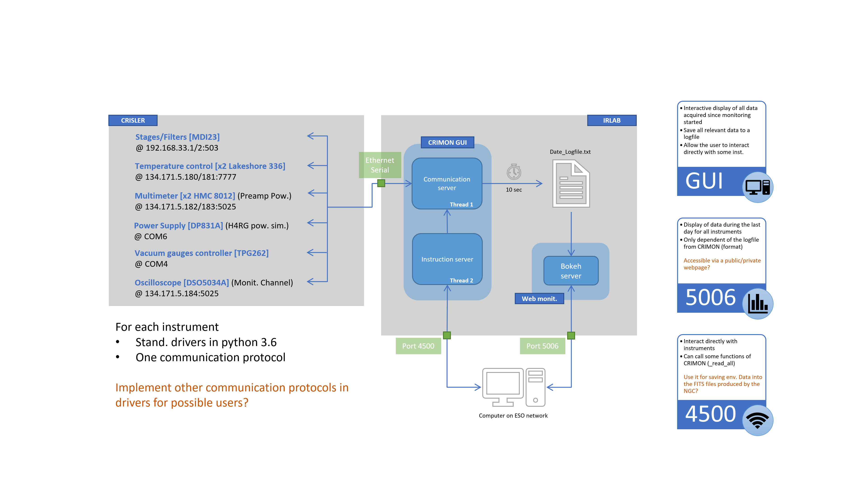

CRIMON functions can be summarized in the following list:

1. Record the data for each instrument that is connected via Serial or Ethernet connexion (with a specific driver written in Python).
2. Display the data recorded in a responsive GUI
3. Centralize the communication for all instruments in a simple interface in the GUI
4. External communications with the instruments can also be done by the use of an instruction server with specific commands. Thus allowing the user to ‘script’ a full experiment.
5. Display the data externally using a bokeh server (separate).

# Configuration

The instrument configuration can be changed in the instrumentation_config_2.json file. For each type of instrument (temperature, pressure, power supply, multimeter…) two fields are mandatory:

* Ident: which will determine which driver it will use [TBD a summary of all instrument drivers]
* Comm: the communication process and the address (serial+com or TCP+IP address)

Other optional fields will be described for each category.

## Temperature

For the temperatures, only Lakeshores 336 are used.

"T": {

"ident":["Lakeshore336",

"Lakeshore336"],

"Comm": [

["TCP", "134.171.5.180"],

["TCP", "134.171.5.181"]

],

"LSCI,MODEL336,336AANG/#######,2.2": ["A", "B", "C"],

"LSCI,MODEL336,LSA163F/LSA15SI,2.7": ["B", "C", "D", "D2", "D3", "D4", "D5"],

"LSCI,MODEL336,LSA22LU/LSA217G,2.8": ["A", "B", "C"]

},

The optional fields are the IDN of the Lakeshores with the channels that we want to record.

## Multimeters

For the voltage and current, mutlmeters HMC8012 are used

"MM": {

"ident":["HMC8012",

"HMC8012"],

"Comm": [

["TCP", "134.171.5.182"],

["TCP", "134.171.5.183"]

],

"Opts": [

["DC_I"],

["DC_V"]

]

},

The optional field is Opts, which will determine in which mode the multimeter will be used (AC/DC I or V).

## Power supply

The power supply used are a Rigol DP831A and a waveform generator DG1062Z

"PSU": {

"ident":["DP831A",

"DG1062Z"],

"Comm": [

["TCP", "134.171.5.188"],

["TCP", "192.168.6.10"]

]

},

## Oscilloscope

For monitoring the bias of the preamp we use a DSO5034 oscilloscope

"OS": {

"ident":["DSO5034"],

"Comm": [

["TCP", "134.171.5.184"]

]

},

# Operation

This section describes the operation of CRIMON. How to start it to record the data and where it can be found. Communication examples will be provided [TBD].

## Starting the monitoring

In order to start the monitoring the CRIMON software must be executed using the correct python distribution. For that, a windows batch script was written and a shortcut can be found on the desktop.

### Below is a step by step description of how to start:

|  |  |  |
| --- | --- | --- |
| 1 | On the desktop, start CRIMON by executing **CRIMON.bat – Shortcut**.  Two windows should be seen in the display, as they are below. The top one is the GUI, the bottom one is the python kernel. **Closing one or the other will shut CRIMON**. |  |
|  | | |
| 2 | On the menu bar on top, click on File > New cooldown directory.  It will create a new directory in folder **C:\Users\irlab\Desktop\COOLDOWN_LOGS**. This folder name will be **DD-MM-YYYY-HH-MM-SS** and will contain every data file started with this session. | |
| 3 | In the Time Sampling entry box below the graph, enter the time sampling for the recording in milliseconds. | |
| 4 | Click on the “Start” button next to the Time Sampling entry  It will start the recording of the data, the recording will be in a txt file located in the folder create in step #2. | |
| 5 | On the desktop, start the webserver by executing **MonitoringIntranet.bat – Shortcut**.  It will allows users to check the cooldown status by going to the address 134.171.26.18:5006 in their web browser. |  |
| Data as displayed on a remote web browser in ESO internal network. | | |

## Interact with the instruments

### Using the GUI

Below the graph display of the data that is being recorded, there are several tabs. Each one correspond to one instrument and will be use to communicate to this instrument using its own protocol.

1. User log: add a note to the current txt files where the data is recorded. It is useful for knowing what happened at a given time when looking at the data after the cooldown is over.
2. Lakeshore commands: this tab allows the user to communicate with the Lakeshores 336. The button at the top allows the user to change the lakeshore he communicates with, you can check which one with the *IDN? command for instruments using the SCPI protocol [See AD1].

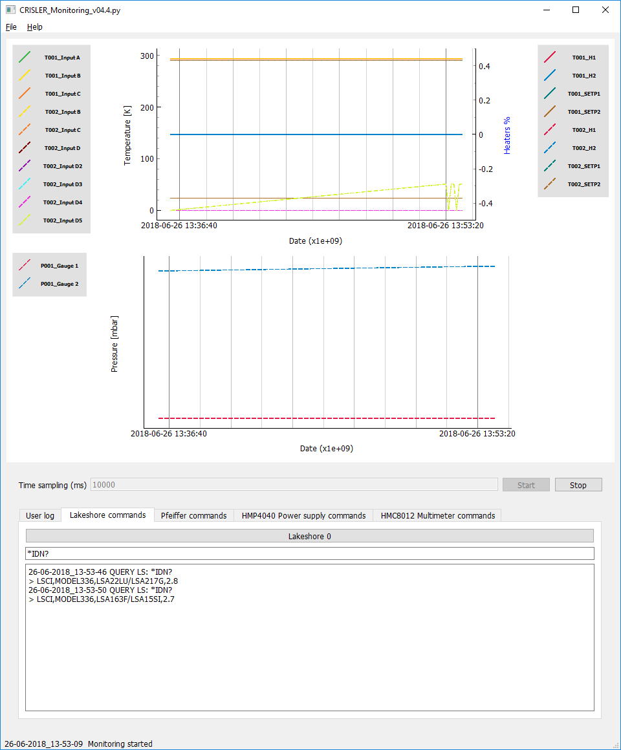

Figure 1 - Lakeshore console in the CRIMON GUI

1. Pfeiffer commands: this tab is empty because no interaction is needed with the vacuum gauge controller.
2. Power Supply command: this tab allows the user to communicate with the Rigol DP831A [See AD2].

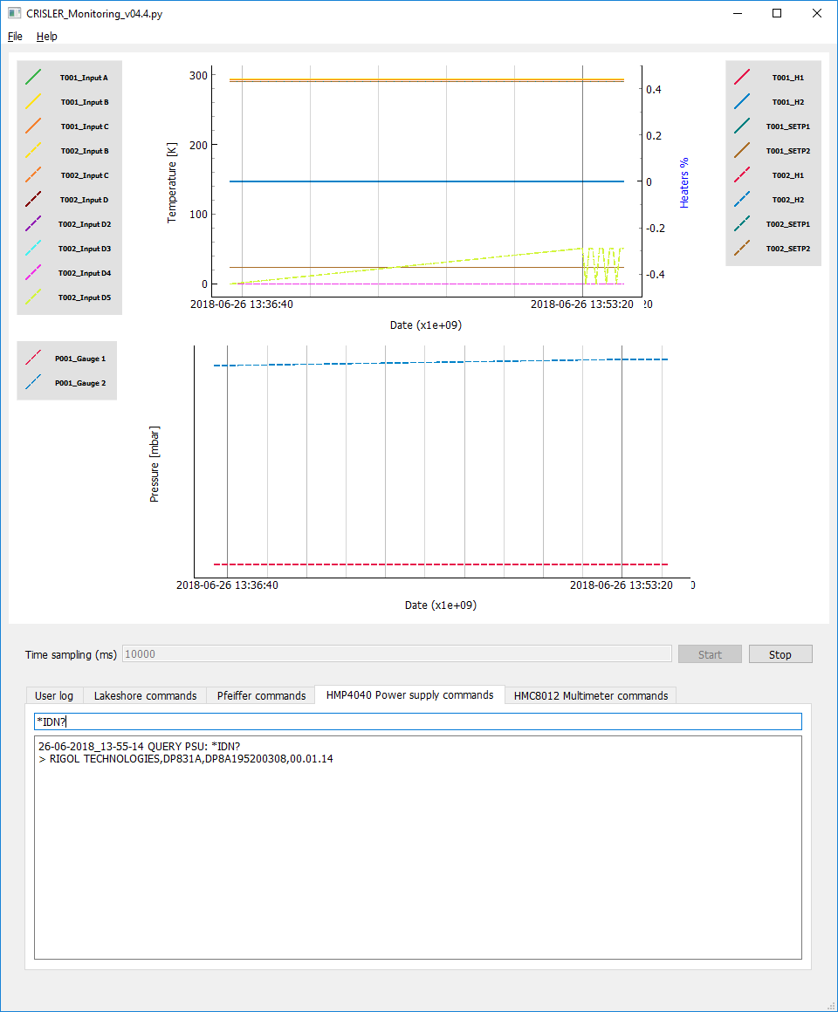

Figure 2 – Power supply console in the CRIMON GUI

1. Multimeter commands: this tab allows the user to communicate with the Rohde & Schwarze HMC8012 multimeters [See AD3]. Like the lakeshores, the button on the top allows the user to switch between them.

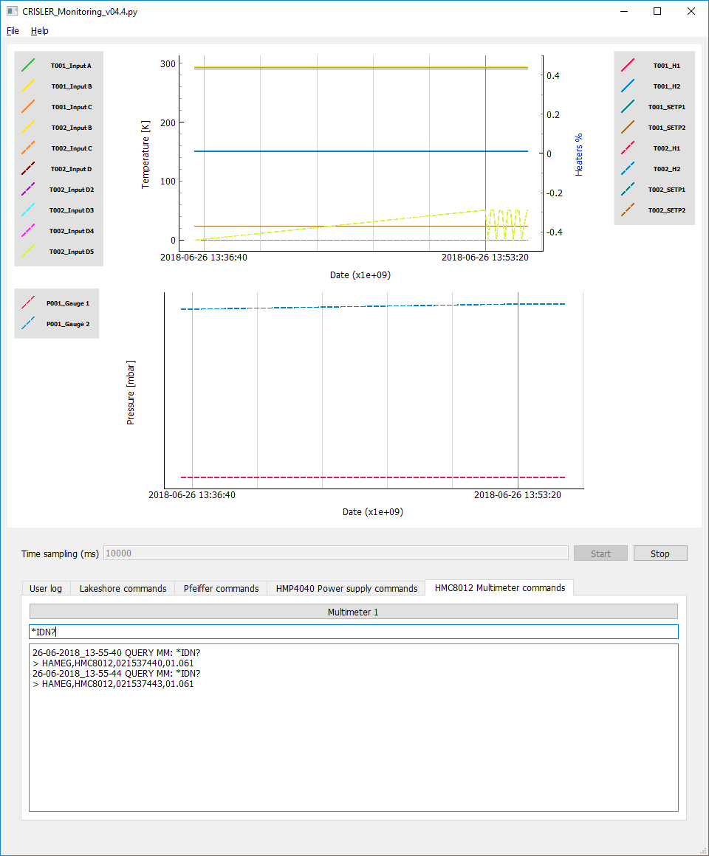

Figure 3 – Multimeters console in the CRIMON GUI

An interesting feature of CRIMON is that all interactions using these consoles are also recorded in the log file in the Notes column. An example of the import of one log file to an excel spreadsheet can be found in AD5 (found in **\\dsraid2\raid\projects\CRISLER\Manuals\UserManual**).

### Using a Python script

In order to communicate with the instruments using a script, the CRIMON interface must be started. Recording can run in parallel, but is not necessary to start communicating with python.

In order to communicate with the instruments using the CRIMON instruction server, you must connect through a socket. The information needed are the IP address of the computer 134.171.36.18 as well as the port 4500.

The instruction server is fairly simple and is only available as for testing purposes for now, a more robust interface might be implemented if needed.

In order to see what the user can do with the user can do with the instruction server, please refer to the python script referred as AD6 (found in **\\dsraid2\raid\projects\CRISLER\Software\Monitoring\test_scripts**).

# Data visualisation

After cooling down, the user should have one or several text files with the same format. For visualizing the data, the user can copy the data of each file to an excel spreadsheet. But the sheer volume of data that will be inside the spreadsheet renders excel slow for very simple operations.

Using python, a written script can be used to merge the files together and display the data. This display also allows to see the closest datapoint to the cursor (see python script referred as AD7).

## Step by step

|  |  |
| --- | --- |
| 1 | Copy the python script **ResultsCooldown.py** (found in **\\dsraid2\raid\projects\CRISLER\Software\Monitoring\test_scripts**). Where the text files are. |
| 2 | Execute the script. Two windows should be seen in the display, as they are below. The top one is the GUI, the bottom one is the python kernel. **Closing one or the other will close the program**. |
|  | |
| 3 | When the user click on one of the plots, in the python kernel, a series of values will be displayed. This is the closest data point to where the user clicked.  If the user clicks outside of the plot nothing happens. |
|  | |

## Notes

This script is compatible with data acquired with CRIMON v0.4.4.

**--- End of document ---**